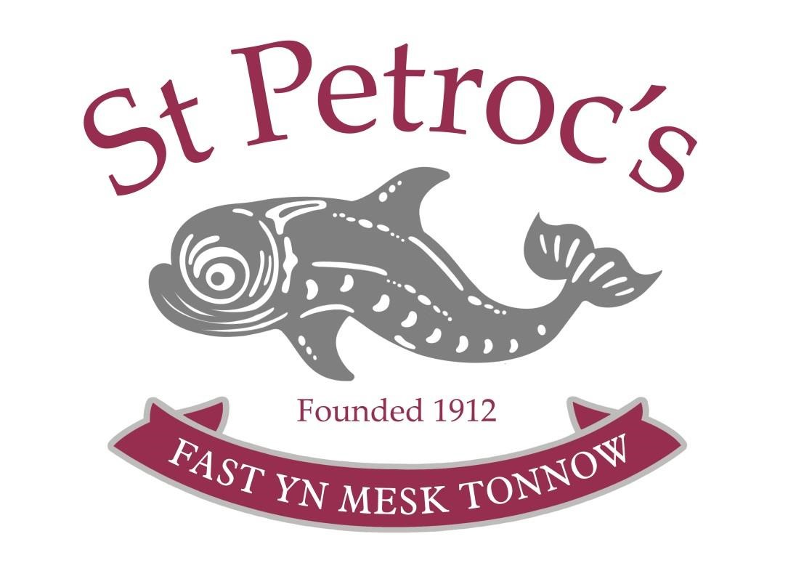

St Petroc’s School
Curriculum Policy for EYFS

Director Lead: Julie Smith
Head of Early Years: Tahira White

Reviewed: September 2023
Next Review Due: September 2024

Children start to learn about the world around them from the moment they are born. The care and education offered by St Petroc’s Nursery helps children to do this by providing all of the children with interesting activities that are right for their age, stage of development and focusing on their interests.
We aim to develop the following through the curriculum:
- Promotion of emotional wellbeing; development of self-esteem, confidence, security and independence
- A preparation for life; learning about taking risks, communication, tolerance, cooperation, aspiration for achievement
- Fostering a love of learning for all; the development of awe and wonder, excitement, enthusiasm, and essential skills
- A social responsibility for all; developing social skills and relationships, respect, communication, accountability, acceptance and empathy
- A quality environment which is calm, secure, stable, safe, healthy and inclusive
- Aspiration for excellence; clear and high expectations, a quality environment and respect for all.
At St Petroc’s, we understand that we are legally required to comply with the Statutory Framework for the Early Years Foundation Stage, which promotes teaching and learning to ensure children’s school readiness and sets the standards that all early years providers must meet to ensure that children learn and develop well, and are kept healthy and safe, and give children the broad range of knowledge and skills that provide the right foundation for good future progress through school and life provide, and we endeavour to meet all these requirements.
The EYFS is based upon four principles, which we follow:
- A Unique Child
- Positive Relationships
- Enabling Environments
- Children develop and learn in different ways

- A Unique Child
At St Petroc’s we recognise that every child is a unique learner who can be resilient, capable, confident and self-assured. We understand that children will develop at varying rates and in individual ways and will come with varying life experiences and interests.
We believe that all our children matter, and we give all our children every possible opportunity to achieve their best and reach their full potential.
We value diversity we treat children and families fairly regardless of race, religion/beliefs, gender or ability.
- Positive Relationships
At St Petroc’s we aim to develop respectful, caring and professional positive relationships with children and their families, other professionals and stakeholders.
We recognise that parents are the child’s first and most enduring educators and ensure their contribution is valued. Our procedures:
- Giving children and parents the opportunity to spend time in the nursery prior to starting school
- Inviting all parents to an induction meeting
- Providing written information on our website
- Offering parents termly opportunities to talk about their child’s progress with the class teacher
- Informing parents about what we have been doing via newsletters/website/social media etc
- Offering an open door policy enabling parents to speak to a member of staff in private
- Ensuring parents have free access to their child’s learning journey and encouraging contributions from the family
- Providing a written report when children leave the Nursery
- Where appropriate, working with parents on transition
- Offering information about the curriculum throughout the year
- Inviting parents to a termly session when parents can join their child in the nursery
- Encouraging parents to talk to the child’s teacher if there are any concerns.

All staff involved with the EYFS aim to develop good relationships with all children, interacting positively with them and taking time to listen to them and recognising what makes them unique. In our setting, all adults working with the children have an identified group of children for which they are the key person; however, we ensure that all staff are aware of all the children in our care to ensure consistency of care.
Learning journeys are passed on to the next school with a request that they are returned to the parent.
We have strong links with other professionals and other health professionals and work with them to provide the best possible provision for the children in our care.

- Enabling Environments
At St Petroc’s we recognise that the whole environment (both interior and exterior) plays a key role in supporting and extending the children’s development.
Each child will be assigned a key person and St Petroc’s has the recommended ratio of adults to children in the setting. This helps us to:
• Give time and attention to each child;
• Talk with the children about their interests and activities;
• Help children to experience and benefit from the activities we provide; and
• Allow the children to explore and be adventurous in a safe environment.

We plan for a range of experiences whilst encouraging children to make their own choices and equipment is freely available. Children’s interests are observed and planned for. The environment is organised to allow children to explore and learn securely and safely. There are areas where the children can be active, be quiet and rest. The environment is set up to provide opportunities for all the areas of learning, where children are able to find and locate equipment and resources independently. It offers the children space to explore, use their senses and be physically active and exuberant. Resources are chosen with care and maintained and checked regularly.
- Children develop and learn in different ways
We adhere to the statutory framework for the EYFS and use associated guidance as a basis for planning provision. Our overall aim when planning for children’s learning and development is to meet the needs of the children in our care regardless of age, gender, race, religion/belief or ability. This is paramount. Through play our children learn to explore and develop their learning in order to help them make sense of the world. Play is essential for children’s development, building their confidence as they learn to explore, to think about problems, and relate to others. They are given the opportunity to practice skills, think creatively, play with others as well as on their own, communicate effectively, solve problems and understand the need for rules. We believe that children learn best when they are motivated and interested and when they are given the freedom to develop some independence and control over their own learning. As they develop confidence, they are able to have greater control over decision making allowing them to take greater ownership of their learning. Adult support is used effectively to enhance learning opportunities and encourage children to think critically and ask questions extending their learning. We observe children’s’ interests. What children are learning and how children are learning.
The EYFS learning and development requirements comprise seven areas of learning and development, which St Petroc’s follow.
- Communication and language
We ensure that the quality of conversations that children have with adults and peers throughout the day by commenting on or taking an interest in what they are doing and developing their vocabulary. We read frequently to children, and engage them actively in stories, non-fiction, rhymes and poems and provide them with extensive opportunities to use and embed new words in a range of contexts, and use story telling to share children’s ideas
- Physical development
We believe that physical activity is vital in children’s all-round development, enabling them to pursue happy, healthy and active lives. St Petroc’s creates games and provides opportunities for play both indoors and outdoors, adults can support children to develop their core strength, stability, balance, spatial awareness, co-ordination and agility. Gross and fine motor skills are developed through play and exploration.
- Personal, social and emotional development
We believe that children’s personal, social and emotional development (PSED) is crucial for children to lead healthy and happy lives and is fundamental to their cognitive development. Strong and supportive relationships with adults at St Petroc’s nursery enable children to learn how to understand their own feelings and those of others. Children are supported to manage emotions, develop a positive sense of self, set themselves simple goals, and have confidence in their own abilities. Through adult modelling and guidance, children learn how to look after their bodies, including healthy eating, and manage personal needs independently. Through supported interaction with other children, they learn how to make good friendships, co-operate and resolve conflicts peaceably.
- Literacy
At St Petroc’s , children are encouraged to develop a life-long love of reading, consisting of language comprehension and word reading. Writing involves transcription (spelling and handwriting) and composition. Children will articulate ideas and structure them in speech, before writing marks to indicate their articulations, teachers will then annotate the words underneath the marks to indicate the meanings that the children have articulated.
- Mathematics
St Petroc’s believes that developing a strong grounding in number is essential so that all children develop the necessary building blocks to excel mathematically. Children should be able to count confidently, develop a deep understanding of the numbers to 10, the relationships between them and the patterns within those numbers. By providing frequent and varied opportunities to build and apply this understanding and rich opportunities for children to develop their spatial reasoning skills across all areas of mathematics including shape, space and measures.
- Understanding the world
St Petroc’s guides children to make sense of their physical world and their community. The frequency and range of children’s personal experiences increases their knowledge and sense of the world around them. Listening to a broad selection of stories, non-fiction, rhymes and poems fosters their understanding of our diverse world.
- Expressive arts and design
St Petroc’s supports children’s artistic and cultural awareness and their imagination and creativity and gives children regular opportunities to engage with the arts.

Early Learning Goals
The level of development children should be expected to have attained by the end of reception class is defined by the early learning goals (ELGs), including listening, attention and understanding; speaking; self-regulation; managing self; building relationships; gross motor skills; fine motor skills; comprehension; word reading; writing; number; numerical patterns; past and present; people, culture and communities; the natural world; creating with materials; being imaginative and expressive. St Petroc’s nursery will look at the child as a whole and see where their weaknesses lie and plan for the child’s individual needs; parents will receive a report on the 7 areas of learning above and the school where the child will attend reception will be contacted and a discussion about each individual child will be held; teachers from the child’s school will spend time in St Petroc’s nursery and the child will attend for taster sessions in school for perhaps one hour per week.
Home Language Not English
For children whose home language is not English, St Petroc’s nursery will take reasonable steps in conjunction with parents to provide opportunities for children to develop and use their home language in play and learning, supporting their language development at home.

In planning and guiding what children learn, St Petroc’s nursery will reflect on the different rates at which children are developing and adjust their practice appropriately.
Three characteristics of effective teaching and learning are:
- playing and exploring - children investigate and experience things, and ‘have
a go’
- active learning - children concentrate and keep on trying if they encounter
difficulties, and enjoy achievements
- creating and thinking critically - children have and develop their own ideas,
make links between ideas, and develop strategies for doing things

Linked Policies
This policy also links to our policies on:

• Allegations against staff
• Anti-bullying
• Attendance
• Complaints
• Drug Education
• Health & Safety
• Medical
• On-line Safety, including staff use of mobile phones and cameras
• Positive Behaviour
• PSHE
• Recruitment and selection of staff
• Risk Assessment
• Sex and Relationships Education
• Staff Code of Conduct
• Teaching and Learning

