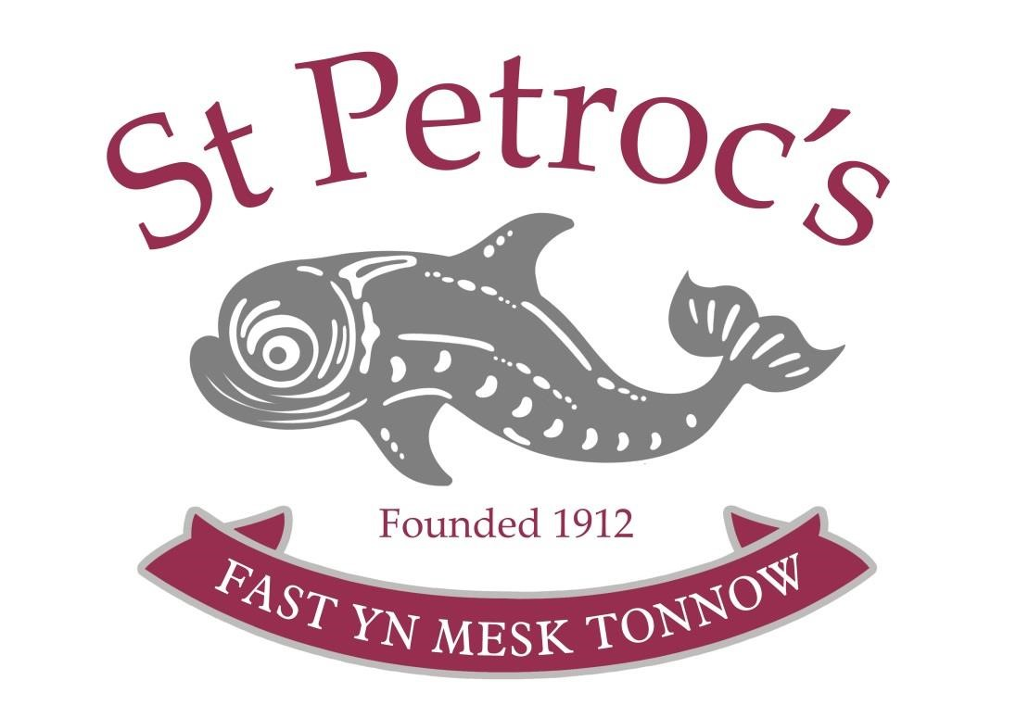

Equal Opportunities Policy
(including EYFS)

Reviewed by the Governing Body April 2023
Next full review by the Governing Body April 2024

Equal Opportunities at St Petroc's

Introduction
St Petroc’s School prides itself on being an inclusive, tolerant organisation and a diverse community; it is firmly committed to promoting equal opportunities for all current and prospective members of the community, whether they be staff or pupils. It is committed to providing an environment that is free from unlawful or unfair discrimination on the grounds of age, race, ethnicity, gender, sexual orientation, disability or religious beliefs and aims to create the conditions whereby pupils and staff are treated solely on the basis of their merits and potential.

A. Pupils and Families
Promoting equal opportunities is fundamental to the aims and ethos of St Petroc’s. We welcome applications from candidates with as diverse a range of backgrounds as possible. This enriches our community and is vital in preparing our pupils for today’s world. We concentrate on educating the individual, to provide a comfortable and welcoming atmosphere where each individual feels valued and can flourish.
St Petroc’s is committed to equal treatment for all pupils, regardless of race or colour, nationality or national or ethnic origins, religion or belief, sex, sexual orientation, pregnancy or maternity, gender reassignment or disability. We believe that the educational experience is enriched if children are exposed to as wide a range of cultural experiences as possible whilst they are developing. We welcome the diversity of family lifestyles and work with all families. We encourage children to contribute stories of everyday life to the setting, and specifically in the Early Years through Tapestry, wall boards, show and tell and circle time.
Parents and carers are encouraged to take part in the life of the setting. We work in partnership with families to ensure that dietary requirements of children that arise from medical, religious or cultural needs are met wherever possible. We help children to learn about a range of food and of cultural approaches to mealtimes and eating habits, and to respect the differences among them.
We welcome applications from pupils with special needs and disabilities and refer parents to our policy covering Special Education Needs (SEN), learning difficulties, and disability. For our Early Years children, we provide information on our local offer of provision for children with SEN on the Care and Support in Cornwall website: www.supportincornwall.org.uk.

Code of Conduct
The Early Years Manager plays an active role in monitoring the implementation of St Petroc’s policy on equal opportunities. The curriculum in the Early Years encourages children to develop positive images of themselves, as well as others. These lessons aim to:
- Support all pupils in learning about and deepening their understanding of British values, culture and systems (for more information, please refer to our British Values Policy)
- Promote tolerance of each other and respect for each other's position within St Petroc’s community
- Promote positive images and role models to avoid prejudice and raise awareness of related issues
- Foster an open-minded approach and encourage pupils to recognise the contributions made by different cultures, including celebrating different festivals
- Understand why and how we will deal with offensive language and behaviour
- Understand why we will deal with any incidents promptly and in a sensitive manner.
Harassment in all its forms is unlawful and unacceptable; our behavioural management and antibullying policies contain clear procedures for dealing with unlawful discrimination. As part of their inset training, teaching staff receive training on recognising and responding to discrimination and harassment.
A successful equal opportunities policy requires strong and positive support from parent and guardians, and full acceptance of St Petroc’s ethos of tolerance and respect. St Petroc’s therefore expects parents and guardians to support and honour this policy.

Access
In the Early Years, we will make reasonable adjustments to accommodate the needs of the families.

English as an Additional Language
At the time of writing, we currently have one pupils with EAL. We are fully open to them and are aware that a lack of fluency in the English language is a potential barrier to a full curricular entitlement. St Petroc’s policy is to ensure that these pupils have an appropriate curriculum, which includes EAL support. The purpose of this support is to encourage and develop the individual’s English skills to enable that person to have access to a full curriculum and be fully integrated within the community. Additional EAL lessons can be arranged at the parent’s expense. For further information, please see our EAL policy.

Collective Worship and Curriculum
The Early Year’s Manager will consider written requests from parents for pupils to be excused from any acts of worship. They may take expert advice, and where necessary, meet with the parents to discuss the implications of such a request.

The law about religious discrimination does not apply to the curriculum. St Petroc’s aims to cover a wide range of religious beliefs in its teaching.

Complaints
We hope that parents do not have any complaints about the operation of our equal opportunities policy, but a copy of St Petroc’s complaints procedure is available on St Petroc’s website or can be provided to parents or guardians on request.

B. Employees
St Petroc’s is an equal opportunities employer.
In order to promote an environment within which St Petroc’s can call upon the widest possible range of knowledge, skill and experience, as well as ensuring compliance with the relevant legislation and codes of practice, we are committed to achieving and maintaining a workforce which represents the population within our recruitment area. This pertains to race or colour, nationality or national or ethnic origins, religion or belief, sex, sexual orientation, pregnancy or maternity, marital or civil partnership status, gender reassignment, age, and disability (together known as "Protected Characteristics").
To this end, the Early Year’s Manager shall regularly review the operation of St Petroc’s recruitment, promotion, training and development policies to ensure that no applicant for employment or member of staff is disadvantaged by conditions or requirements which cannot be shown to be justifiable.
No employee or volunteer or prospective employee or volunteer will receive unfair or unlawful treatment on the grounds of a Protected Characteristic (as defined in the Equality Act 2010), because they are perceived to have a Protected Characteristic or because they are associated with someone who has a Protected Characteristic, in particular but not only, in relation to:
- Recruitment and selection
- Promotion, transfer & training opportunities
- Benefits, terms and conditions of employment
- Grievance and disciplinary procedures
- Termination of employment including redundancies
- Conduct at work
The principles of non-discrimination and equality of opportunity also apply to the way in which staff must treat visitors, pupils, parents, suppliers and former members of staff.

Implementation
St Petroc’s, with the assistance of the staff, will:
- Break down any barriers to equality of opportunity which may prevent staff members realising their full potential
- Advertise vacancies and ensure job selection criteria are appropriate for the job
- Promptly and fully investigate all complaints of discrimination and harassment, taking appropriate action where necessary
- Ensure that all members of staff are fully informed and trained on this policy
- Monitor the composition of St Petroc’s and the effects of its recruitment practices
- Regularly review and examine existing procedures to ensure they are not discriminatory in their operation
- Ensure language used in official communication reflects the letter and spirit of the policy

Recruitment and Selection
The staffing process is governed by St Petroc’s principles of non-discrimination and is designed to achieve the best match between, on the one hand, the individual's knowledge and skills, experience and character and, on the other hand, the requirements of the vacant post, recognising the need for flexibility to respond to changing conditions.
The capability of the individual to perform in the position will be the major selection criterion but the ability both to work with others and to be trained, coupled with individual potential will be taken into account. All applicants will be dealt with courteously and as expeditiously as possible.
Carefully selected and validated skills and/or psychometric tests may be used as part of the selection process and will be administered by a trained tester.
Appointments will be confirmed on receipt of satisfactory references and DBS checks (and in the absence of prohibition orders) and/or medical report, and/or satisfactory completion of a probationary period. For specific roles and only where necessary, St Petroc’s will apply the exceptions permitted under the Equality Act to the recruitment process.

Disability
If a member of staff is disabled or becomes disabled, we encourage them to inform their line manager about their condition so that St Petroc’s can support them as appropriate.
A disability will not of itself justify the non-recruitment of an applicant for a position at St Petroc’s. Such reasonable adjustments to the application procedures shall be made as are required to ensure that applicants are not disadvantaged because of their disability.
If a member of staff experiences difficulties at work because of any disability, they should contact the Early Years Manager or their Deputy to discuss any reasonable adjustments that would help overcome or minimise the difficulty. If the Early Year’s Manager considers a particular adjustment would not be reasonable the reasons will be explained to the member of staff and St Petroc’s will try to find an alternative solution where possible. Once an adjustment has been made, its operation may need to be reviewed at agreed intervals, to assess its continuing effectiveness.
St Petroc’s will make such adjustments to work arrangements or school premises as are reasonable to enable a disabled staff member to carry out his or her duties. This could include, but is not limited to, consideration of the provision of specialist equipment, job redesign and/or flexible hours.
Where during the course of their employment a disabled member of staff recognises their need for a reasonable adjustment to be made to work arrangements or School premises, he or she should discuss this requirement with the Early Years Manager or their Deputy.

Dignity at Work
Staff should not engage in any behaviour or conduct which may amount to harassment of another person at work. Harassment of any kind is regarded as a disciplinary offence and in serious instances may lead to instant dismissal.
Harassment may take the form of unwanted conduct that is related to a relevant Protected Characteristic, which is perceived as affecting an employee's dignity at work. It may also take the form of unwanted conduct towards someone based on their appearance or other personal characteristics, which is perceived as affecting their dignity at work. It is not only unwanted physical contact, assault or propositions; it includes suggestive remarks or gestures, pin-ups, graffiti, offensive comments, jokes and banter. Harassment may include bullying, intimidating behaviour, persistent teasing or constant unfounded criticism of the performance of work tasks, unfair allocation of work and responsibilities, or exclusion from normal work place conversation. It may be directed towards one individual or a group. A single incident can amount to harassment if sufficiently grave.

